Step 1: Goto AWS in search bar type DMS(Data Migration Services) and Select it.

Step 2: Click to Replication instances.

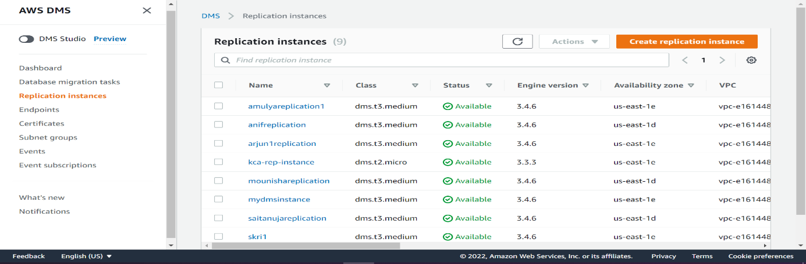

Step 3: Create Replication Instance.

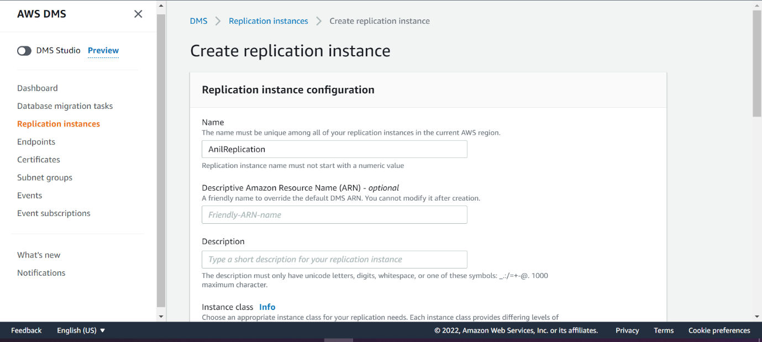

Step 4: after Creation of replication instances, Click on Endpoints and create Endpoints.

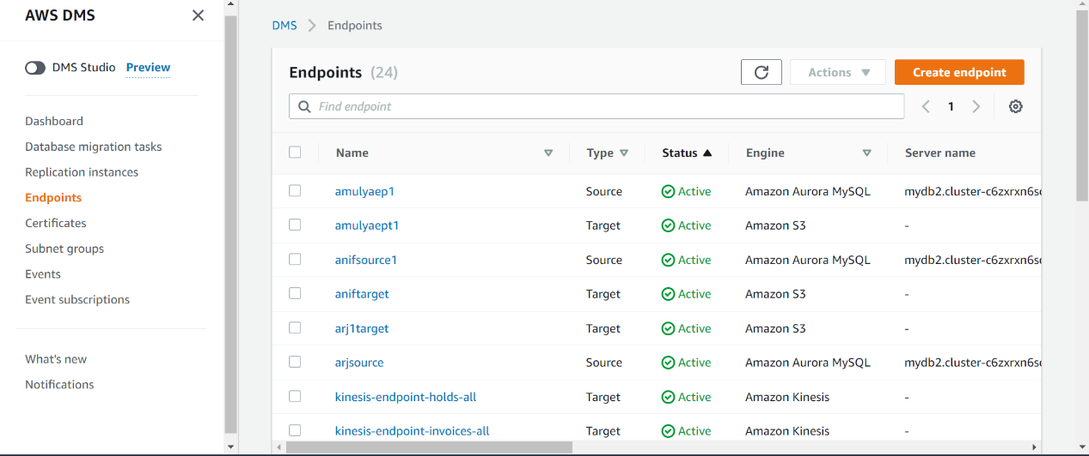

Step 5 : Taking Rds reference and copying endpoint address.

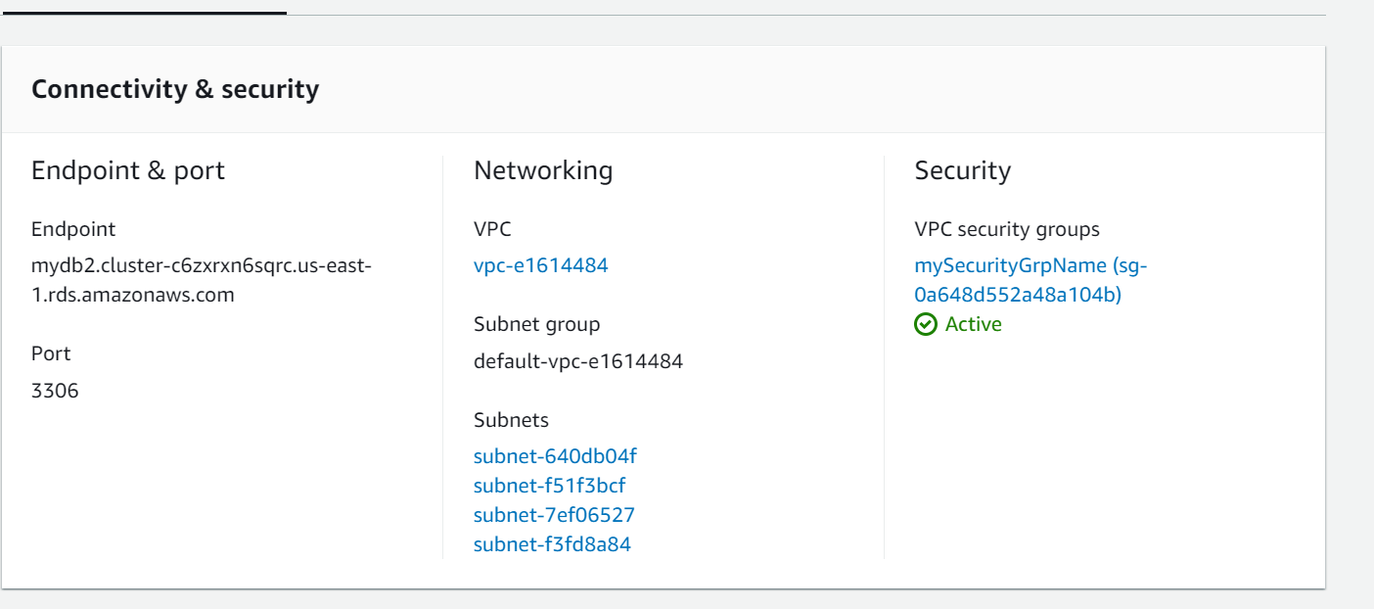

Step 6: Filling Rds Endpoint details into AWS DMS Endpoint.

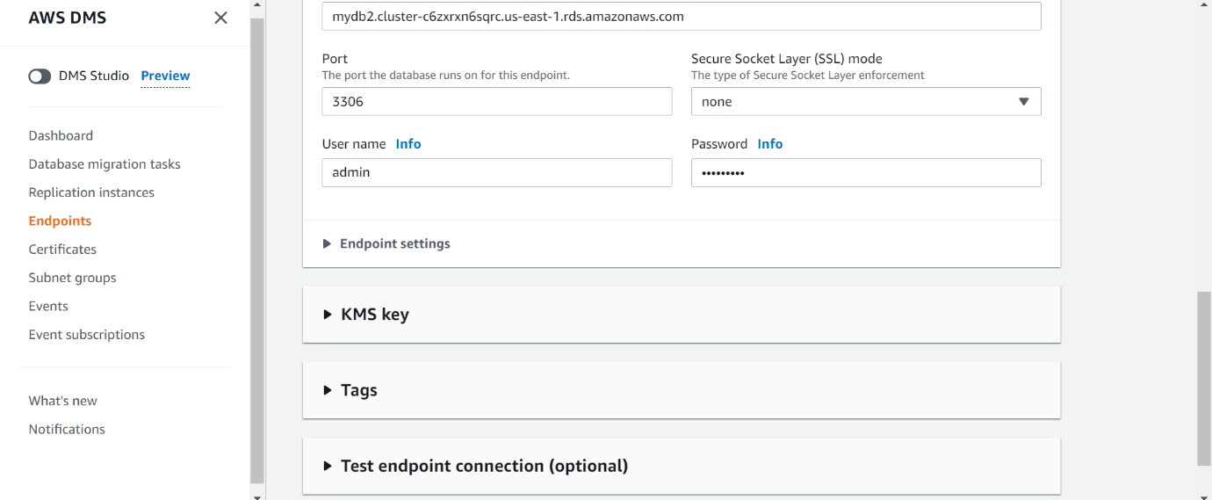

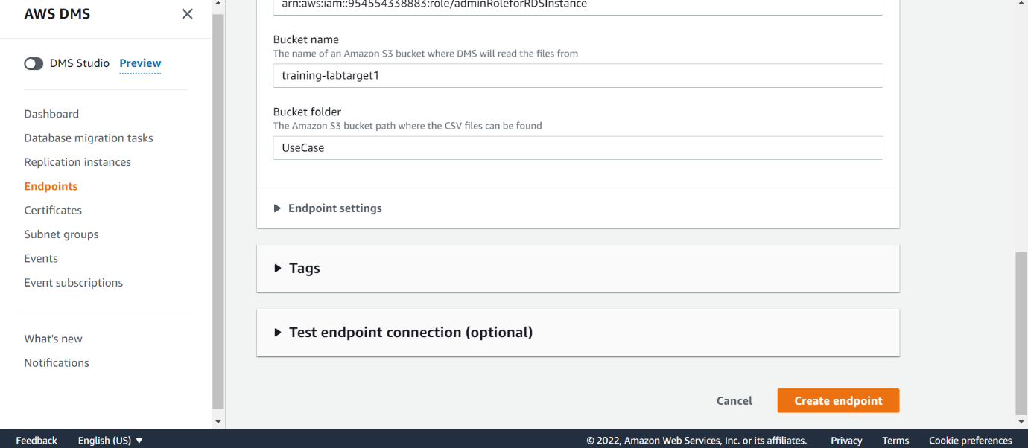

Step 7 : Select Data Migration Task and create a task. Shown below

